# 1.Create a project to demonstrate microservices with Spring BootRestApiOneApplication.java:

package com.example.test; import

org.springframework.boot.SpringApplication; import

org.springframework.boot.autoconfigure.SpringBootApplication; @SpringBootApplication public class

RestApiOneApplication { public static void main(String[] args) {

SpringApplication.run(RestApiOneApplication.class, args);

}

}

# PersonEntity.java :

package com.example.test; import jakarta.persistence.Column; import jakarta.persistence.Entity; import jakarta.persistence.GeneratedValue; import jakarta.persistence.GenerationType; import jakarta.persistence.Id;

@Entity public class PersonEntity {

@Id

@GeneratedValue(strategy = GenerationType.AUTO) @Column(name = "id", updatable = false, nullable = false) private Integer personId;

@Column

private String name; @Column

private Integer age; public PersonEntity() { super();

}

public PersonEntity(Integer personId, String name, Integer age) { super(); this.personId = personId; this.name = name; this.age = age;

}

public Integer getPersonId() { return personId;

}

public void setPersonId(Integer personId) { this.personId = personId;

}

public String getName() { return name;

}

public void setName(String name) { this.name

= name;

}

public Integer getAge() { return age;

}

public void setAge(Integer age) { this.age = age;

}

}

# PersonRepository.java:

package com.example.test; import

org.springframework.data.jpa.repository.JpaRepository; import org.springframework.stereotype.Repository;

@Repository public interface PersonRepository extends JpaRepository<PersonEntity,

Integer> {

}

# PersonService.java:

package com.example.test; import java.util.HashMap; import java.util.Map; import

org.springframework.beans.factory.annotation.Autowired; import org.springframework.stereotype.Service; import org.springframework.web.client.RestTemplate;

@Service public class PersonService {

@Autowired

PersonRepository personRepository;

RestTemplate restTemplate = new RestTemplate();

public PersonResonse getPerson(int personId){ final String uri =

"http://localhost:8082/webapitwo/hobby/{personId}";

Map<String, Integer> params = new HashMap<String, Integer>(); params.put("personId", personId);

String result = restTemplate.getForObject(uri, String.class, params);

PersonEntity pe=personRepository.findById(personId).get(); PersonResonse pr=new PersonResonse();

pr.setPersonId(pe.getPersonId()); pr.setName(pe.getName()); pr.setAge(pe.getAge()); pr.setHobby(result);

return pr;

}

public void addPerson(PersonEntity pe){ personRepository.save(pe);

}

}

# PersonController.java:

package com.example.test; import

org.springframework.beans.factory.annotation.Autowired; import org.springframework.web.bind.annotation.PathVariable; import org.springframework.web.bind.annotation.RequestBody; import

org.springframework.web.bind.annotation.RequestMapping; import org.springframework.web.bind.annotation.RequestMethod; import org.springframework.web.bind.annotation.RestController;

@RestController

@RequestMapping(path = "/webapione") public class PersonController {

@Autowired

PersonService personService;

@RequestMapping("/person/{personId}") public

PersonResonse getPerson(@PathVariable int personId){ return personService.getPerson(personId);

}

@RequestMapping(method=RequestMethod.POST, value="/person") public void addPerson(@RequestBody PersonEntity pe ) {

personService.addPerson(pe);

}

}

# PersonResonse.java :

package com.example.test; public class PersonResonse {

private Integer personId;

private String name; private Integer age; private String hobby; public Integer

getPersonId() { return personId;

}

public void setPersonId(Integer personId) { this.personId = personId;

}

public String getName() { return name;

}

public void setName(String name) { this.name = name;

}

public Integer getAge() { return age;

}

public void setAge(Integer age) { this.age = age;

}

public String getHobby() { return hobby;

}

public void setHobby(String result) { this.hobby = result;

}

}

# application.properties:

server.port=808

spring.application.name=RestApiOne

# pom.xml :

<?xml version="1.0" encoding="UTF-8"?> <project xmln[s="h](http://maven.apache.org/POM/4.0.0)ttp[://maven.apache.org/POM/4.0.0"](http://maven.apache.org/POM/4.0.0)

xmlns:xs[i="h](http://www.w3.org/2001/XMLSchema-instance)ttp[://www.w3.org/2001/XMLSchema-instance"](http://www.w3.org/2001/XMLSchema-instance) xsi:schemaLocation[="h](http://maven.apache.org/POM/4.0.0)tt[p://maven.apache.org/POM/4.0.0](http://maven.apache.org/POM/4.0.0) https://maven.apache.org/xsd/maven-4.0.0.xsd">

<modelVersion>4.0.0</modelVersion>

<parent>

<groupId>org.springframework.boot</groupId>

<artifactId>spring-boot-starter-parent</artifactId>

<version>3.1.0</version>

<relativePath/> <!-- lookup parent from repository --> </parent>

<groupId>com.example</groupId>

<artifactId>RestApiOne</artifactId>

<version>0.0.1-SNAPSHOT</version>

<name>RestApiOne</name>

<description>Demo project for Spring Boot </description>

<properties>

<java.version>20</java.version>

</properties>

<dependencies>

<dependency>

<groupId>org.springframework.boot</groupId>

<artifactId>spring-boot-starter-data-jpa</artifactId>

</dependency>

<dependency>

<groupId>org.springframework.boot</groupId>

<artifactId>spring-boot-starter-web</artifactId>

</dependency>

<dependency>

<groupId>com.h2database</groupId>

<artifactId>h2</artifactId>

<scope>runtime</scope>

</dependency>

<dependency>

<groupId>org.springframework.boot</groupId>

<artifactId>spring-boot-starter-test</artifactId>

<scope>test</scope>

</dependency>

</dependencies>

<build>

<plugins>

<plugin>

<groupId>org.springframework.boot</groupId>

<artifactId>spring-boot-maven-plugin</artifactId>

</plugin>

</plugins>

</build>

</project>

# Output :

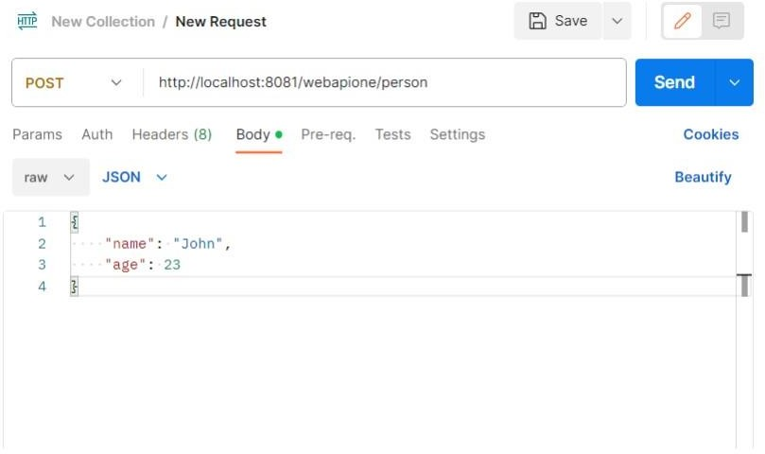

**RestApiTwoApplication.java:**

package com.example.test; import

org.springframework.boot.SpringApplic ation; import

org.springframework.boot.autoconfigur e.SpringBootApplication;

@SpringBootApplication public class RestApiTwoApplication { public static void main(String[] args) {

SpringApplication.run(RestApiTwoApplication.class, args);

}

}

# HobbyEntity.java :

package com.example.test; import jakarta.persistence.Column; import jakarta.persistence.Entity; import jakarta.persistence.GeneratedValue; import jakarta.persistence.GenerationType; import jakarta.persistence.Id;

@Entity public class HobbyEntity {

@Id

@GeneratedValue(strategy = GenerationType.AUTO)

@Column(name = "id", updatable = false, nullable = false) private Integer id;

@Column

private Integer personId; @Column

private String name;

public HobbyEntity() { super();

}

public HobbyEntity(Integer personId, String name) { super(); this.personId = personId; this.name = name;

}

public Integer getPersonId() { return personId;

}

public void setPersonId(Integer personId) { this.personId = personId;

}

public String getName() { return name;

}

public void setName(String name) { this.name = name;

}

}

# HobbyRepository.java :

package com.example.test; import

org.springframework.data.jpa.repository.JpaRepository; import

org.springframework.data.jpa.repository.Query; import org.springframework.stereotype.Repository;

@Repository public interface HobbyRepository extends JpaRepository<HobbyEntity,

Integer> {

@Query("SELECT h.name FROM HobbyEntity h WHERE h.personId=:personId") public String

findByPersonId(Integer personId);

}

# HobbyService.java :

package com.example.test; import

org.springframework.beans.factory.annotation.Autowired; import org.springframework.stereotype.Service;

@Service public class HobbyService {

@Autowired

HobbyRepository hobbyRepository;

public String findByPersonId(int personid){ return hobbyRepository.findByPersonId(personid);

}

public void addHobby(HobbyEntity he){ hobbyRepository.save(he);

}

}

# HobbyController.java:

package com.example.test; import

org.springframework.beans.factory.annotation.Autowired; import org.springframework.web.bind.annotation.PathVariable; import org.springframework.web.bind.annotation.RequestBody; import

org.springframework.web.bind.annotation.RequestMapping; import org.springframework.web.bind.annotation.RequestMethod; import org.springframework.web.bind.annotation.RestController;

@RestController

@RequestMapping(path = "/webapitwo") public class HobbyController {

@Autowired

HobbyService hobbyService;

@RequestMapping("/hobby/{personid}") public String findByPersonId(@PathVariable int personid){ return hobbyService.findByPersonId(personid);

}

@RequestMapping(method=RequestMethod.POST, value="/hobby") public void addHobby(@RequestBody HobbyEntity he ) { hobbyService.addHobby(he);

}

}

# application.properties:

server.port=8082

spring.application.name=RestApiTwo

# Output:

